**2. Assignment**

1. 1. Create an Azure Container Registry and connect it to Docker running in

VM

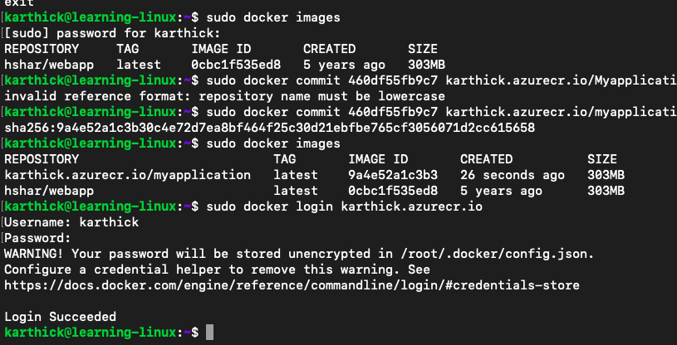

2. Upload the image you created in this Azure to container registry

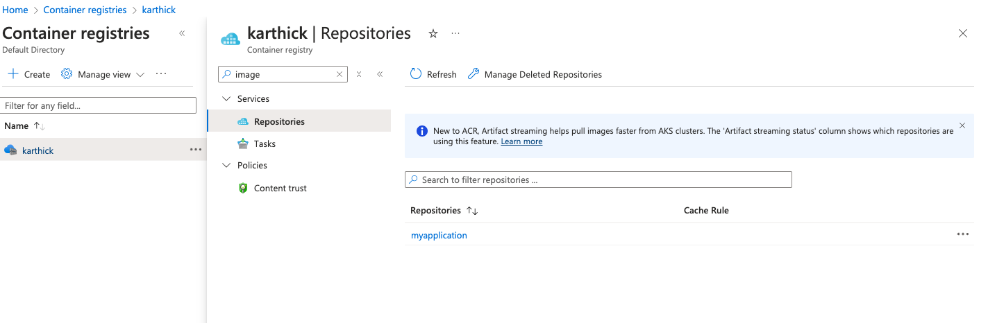

3. Create an app service to deploy the same image

